2001: a space r.a.s.c.
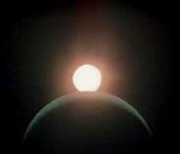

London Centre
June 25 ~ July 2, 2001

General
Assembly
Programme
Guide

a new millennium … anew GA

“I am putting myself to the fullest possible use,
which is all I can think that any conscious entity
can ever hope to do.”

The Royal Astronomical Society of Canada, London Centre
La Société Royale D'Astronomie du Canada, Centre de London
GA events, locations, times, costs and enjoyment level are subject to change with some notice. No carbon-based biped life form was harmed in the making of this booklet. All rights reserved. For what reason we don't know. This booklet contains 100% recycled supernova material. In no event shall the publisher be liable for any direct, indirect, incidental, special, exemplary, or consequential damages arising in any way out of the use of this publication. Permission to copy in whole, or in part, for any purpose, requires the OK of the London Centre.

3

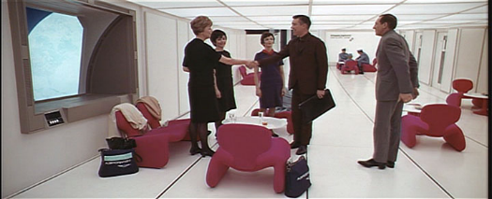
GREETINGS AND SALUTATIONS
Welcome to London town.
May your stay be eventful
and enlightening, joyous and enjoyable, memorable and Fun.
The London Centre takes pleasure in welcoming you to the Society’s Two Thousand and One General Assembly.

REGISTRATION
Enclosed in your registration package along with this programme should be the following material. Please check to make sure you have everything you need:
- Name Tag
- pre-ordered items (GA 2001 shirts)
- Receipt (if requested)
- Comment Sheet
- London Visitor Booklet and London Discovery Guide
- Campus Map

Available at the registration desk:
Registration Centre
Room G1042 Hours
Thursday 18h to 24h
Friday 09h to 24h
Saturday 09h to 17h
- Polaris, the newsletter of the London Centre
- Bus Schedules
- seti@fanshawe phase I answers; Phase II
- GA 2001 shirts
- List of Delegates (from the Web site)

NAME TAG
Your name tag is your ticket to several of the weekend activities, so please make sure you have it with you at all times. If you have registered for only one day, your name tag will be a distinctive colour. Check your name tag carefully to ensure that all paid events are showing.

4

HOSPITALITY SUITE
Party! With the London Centre Relax And Snack Club

The Hospitality Suite was so successful at the 1997 75th anniversary celebration that we think every G.A. should have one.

Our hospitality suite is a special ‘Pod’ in the residence, on the 6th floor (room 620) just steps away from your room, where everyone can congregate and relax. This will be the Centre of social activity all weekend, a point of contact for guests with each other. We will be setting up a slide projector, so if you have some Murphy shots, GA memories, astro photos, etc. then by all means show them here.

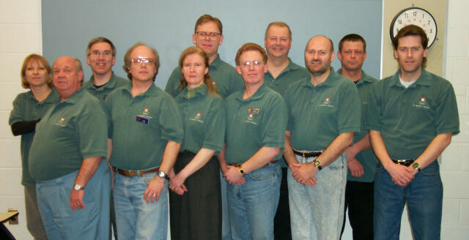

Committee Members Modelling the GA shirts
(Back Row: Valerie, Steve, Peter, John, Dave R.; Front Row: Harold, Dave C., Dianne, Eric, Chris, Shawn) p.s. that’s not a halo around Shawn’s head.

So if you are lost…look for one of these folks…look for green shirts, not blue.
We have green name tags. Our Guests of Honour will be wearing gold shirts.

Special Needs
Remember we asked you to fill out this category on the Web registration? Please let us know if we have missed something. Also if you have a special need that you haven’t told us about then contact a member of the Organizing Committee. Do you need a wake up call? Child care? Ride to the London International Airport? Tarp for your BMW? We will do our best to ensure you have a fantastic time this weekend.

5

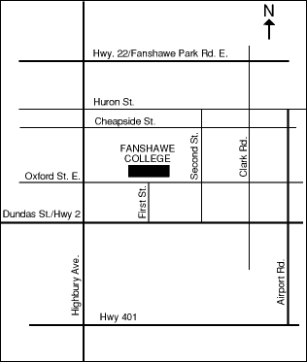
FANSHAWE COLLEGE

RESIDENCE
Reception desk is staffed 24 hours. This is the place to go if you have any security or medical emergencies. If your family needs to get in contact with you during the General Assembly, messages can be left at the reception desk at (519) 452-4440.

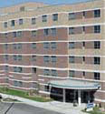
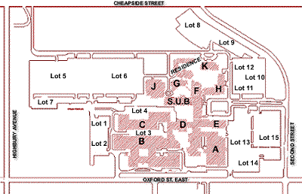

Enter
Here

6

SERVICES

ATM
There are two Automated Teller Machines on-campus. One is by Forwell Hall, S.U.B. (Student Union Building). The other is at the "Junction" of D-building, E-building and F-building, opposite where the Tim Horton's outlet is located.

CHILD CARE
Looks like your room with the beds removed and children added. Available during the BBQ and Gala Banquet, for a fee. Arrangements can be made at the Registration Centre.

COMPUTERS AND NETWORK ACCESS
Chances are that the laptop plugs will not be activated during the GA. The best idea is to see one of the faculty members (Mike Costa or Peter Jedicke or Dave McCarter) and they will help you out. Access to a web browser would be possible and reliable but anyone who wants to hook up their laptop will need IP address and that may be a problem.

CONSTRUCTION
Sorry about that. More information at the Registration Centre.

FIRST AID / MEDICAL EMERGENCY
Non-life threatening … go to the residence main desk.

HOUSEKEEPING
Something threatening not to work … go to the residence main desk.

PARKING
If you are driving on campus, mind the speed bumps! Some are nasty and unmarked. There are a few short-term parking spaces directly in front of the Residence, but make sure you feed the meter and don't leave a vehicle there more than a few minutes! There is a parking lot about 99 steps away.

On Monday, June 25, through to Thursday, June 28, the College is open and parking during the day will cost money. The gates on the lots are removed around 17h on those days.

The College is closed for the Canada Day holiday on Friday, June 29 (go figure). Although this means the on-campus Tim Horton's will be closed, the parking lots will be open free of charge for the weekend.

7
PHOTOCOPIER
There is a photocopier available in the F-building in front of the library. Ask at the Registration Centre for assistance.

VENDING MACHINES
There's a vending machine down the hall from the meeting rooms next to G1001. Ice on the 2nd and 4th floor of the Residence.
The Hospitality Suite should have plenty of nibblies available until everyone's fast asleep. Last resort: Highbury at Cheapside -- Esso, Shell, 7/11, Taco Bell, Swiss Chalet, Harvey's, DQ, Tim Hortons, KFC, Mr. Sub, Fast Eddies, McDonald's and even a church to save your soul. Or try Oxford Street at Second St. for a variety store. If you need ice then come to the Hospitality Suite … I’m sure they will have some … look under the beverages.

GROUP PHOTO
This is a traditional event and it will be done electronically and posted on the website in various formats. Anyone who wants a print can make their own. Also, guests are encouraged to bring their own cameras and take photos of their friends. So, in addition to a few minutes where the group photo is "staged," it will be a general photo shoot for everyone.

The group photo is scheduled for 17h30 sharp Saturday afternoon, between the Northcott Lecture and the Gala Banquet. We hope you will dress up as much as possible for these two events, so the group photo will look as good as possible. Follow the signs PHO.

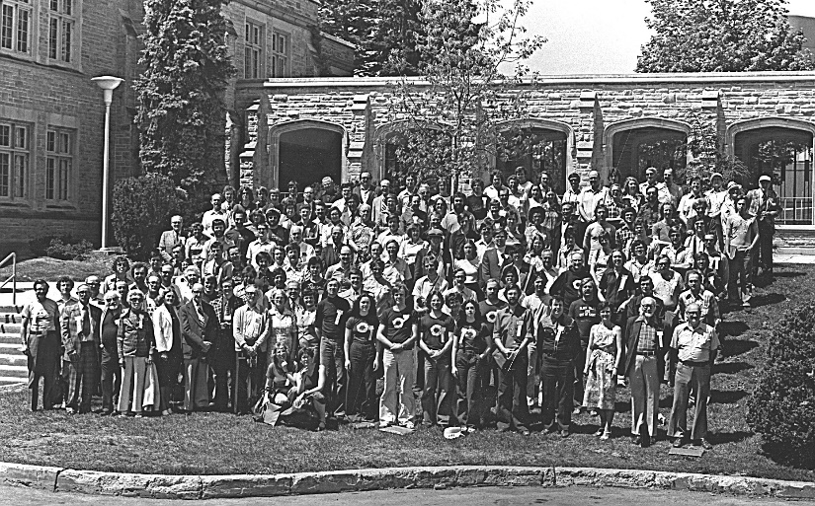

1979
London

8

AROUND LONDON
No matter where you go …there you are
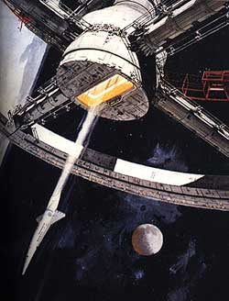
Get out of the Rez and explore. For What To See, Where To Go, Where To Dine, Where To Shop, Calendar of Events, City Map, Family Fun, etc. consult your London Visitor Guide. See below a short list of nearby places. This is not a complete list by far. See a member of the G.A. Organizing Committee at the Registration Centre for more info.

London Transit bus route #4 picks up in front of A building. It will take you downtown. Fare is $2.25.

Cabbies
U-Need-A 438-2121
Aboutown Taxi 432-2222

NEAR FANSHAWE

RESTAURANTS
Fast Food and within walking distance
- On Highbury at Cheapside. Cheapside is the first street north of the residence. Harvey’s; Taco Bell; Swiss Chalet; DQ; Tim Horton’s; KFC; Mr. Sub; Fast Eddie’s; McDonald's.
- Highbury at Huron (next road north of Cheapside): Huron House; Pizza Hut; Archies’s Fish & Chips (look for the lighthouse).
- On Oxford at First Street across the street from Fanshawe College: Carey’s on Oxford; Sammy’s (Soulvaki and burgers).

Casual Food
- Crabby Joe's Tap & Grill. Dundas Street at First Street.
- The Keg. Dundas Street. East of Highbury Ave.
- Kelsey’s, Oxford Street at Gammage. 4 lights west of the campus.
- Roxbury Pub & Grill. 1165 Oxford St. E. 2 blocks west of Highbury Ave.

…continued on page 21

9

MONDAY TO WEDNESDAY
“A day without sunshine is like, well, night.”

Pre-Convention Observing Nights (the "avant-GA")

Have you always wished the General Assembly was a Star Party?

This event, new in 2001, gives you, our guests, a chance to stretch the GA experience by sharing some observing outside of London. Weather permitting, of course! Observing conventions are serious competition for the GA, and this is our way of fighting back!

Everyone is invited to join us on June 25th, 26th and 27th, 2001, for our pre-convention observing nights -- the avant-GA star party. The observing location will be in Southwestern Ontario where we enjoy the most southerly latitudes in Canada. Here, dark skies are available year round even just after the Summer Solstice. Out-of-town guests are welcome and will be provided with transportation to the observing site each night and, as our guests, will have access to telescopes provided by the RASC London Centre and its members.

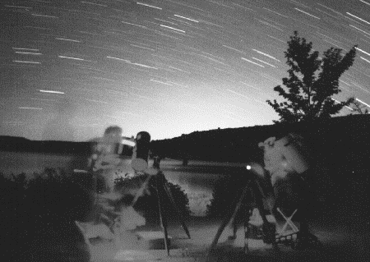
The first observing night will be June 25th, (or the first clear night following) at the Country Estate of Derek Hitchens, located near Alvinston, Ontario. We are planning an evening barbecue before dark to kick off the whole "2001: a space r.a.s.c." experience. We will help you get your own food and we'll have several barbecues for you to cook on.

The second observing night will be on June 26th, (or the first clear night following the event at Derek's place) at the Fingal Wildlife Management Area, located near the shore of Lake Erie. This site provides a great view of the Milky Way around Sagittarius, Scorpius, Ophiuchus and all the way up to the Summer Triangle. Northern observers will appreciate the view of M6 and M7 from this location.

10

The third observing night will be June 27th, and is tentatively set for the Fingal Wildlife Conservation Area, with the option of moving it back to Derek Hitchen's place. Check the GA 2001 website for updates. Washroom facilities will be available at both locations. Electricity will be available at Derek's place but may not be available at the Fingal site.

The price to participate in the Observing Nights is $10, regardless of which nights you participate and regardless of the weather. London Centre member Chris Fleming will be your guide. Transportation will be provided. If you want to go it on your own the maps to Fingal are below.

There are, obviously, many ways to get there from Fanshawe College…we recommend the following: West on Oxford to Highbury Ave. Go south on Highbury Ave. until Hwy 401. West until you get to Union Road. South through Shedden on to County Road 16. Turn right and look for the sign (2.6 km). The Fingal Wildlife Conservation Area is on your left (South). Too far if you get to Iona Rd.

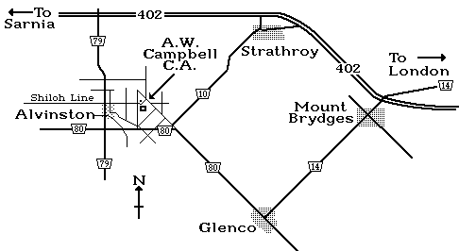
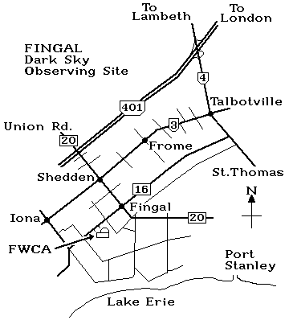

FINGAL site HITCHENS site

Astronomical Information
For your observing log: London is at Longitude 81.250 degrees West and Latitude 42.983 degrees North. Conveniently located under the ISS orbital path.
A city of over 330,000 = lots o’ light pollution.

11

THURSDAY, JUNE 28

Hume Cronyn Memorial Observatory
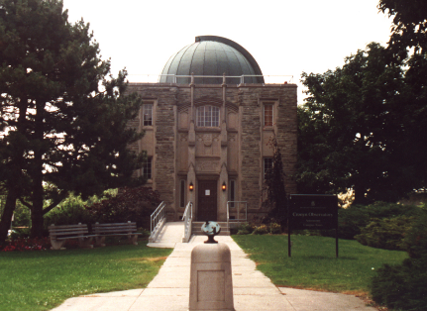
Departure 19h50 – front of the Residence

A visit to London by anyone interested in
astronomy can hardly be complete without
a look at the venerable refractor at the
Hume Cronyn Memorial Observatory
(est. 1940). A bus will shuttle you from the
Residence up to the campus of the
University of Western Ontario. Presuming
the weather is clear, we'll get a look at Mars
near its favourable opposition through the 25 cm (10 in.) refractor.

If you want to go it on your own see the map below. The most direct route is to: Go West on Oxford Street until you get to Wharncliffe Road. Turn Right and go north. The road becomes Western Road and you go north until you get to the gates of the campus. You will have passed the Thompson Arena (the building with the roof supported by cables). There are traffic lights at the gate. Turn right and the Observatory is on your right, on the circle beside Alumni Hall. The parking lot is to the left and behind the Observatory. This is a pay-at-the-booth lot. It may be free or it may not. We won’t know until we get there.

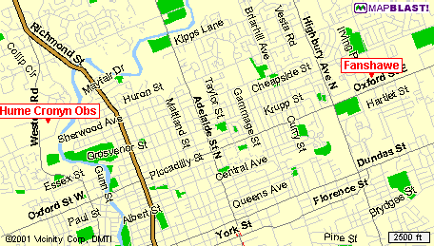

12

FRIDAY, JUNE 29
WHEN WHAT WHERE

07h – 11h Continental Breakfast Residence
Residence Guests Only

09h – 24h Registration Open G1042

09h – 13h Telescope Assembly Demonstration
with “Stargazer” Steve Dodson beside G1042
Steve Dodson will assemble a Dobsonian telescope. DOB
A lucky G.A. participant will win the telescope.

09h30 – 10h30 Astronomy Education Workshop G1019
Morning Session for Astronomers EDU
"How Young Persons Learn about Science"
with Anita Elworthy from Let's Talk Science
Session Chairs: Kelly Sibthorpe and Bob Duff
The Astronomy Education Workshop is an opportunity to take advantage of the new Ontario school curriculum topics that deal with astronomy. The morning session is aimed at astronomers who want to volunteer to visit school classrooms. The afternoon session is for Teachers.

10h30 Coffee Break

11h - 12h30 Astronomy Education Workshop G1019
Morning Session for Astronomers EDU
Panel Discussion
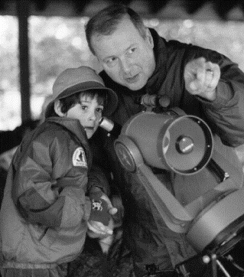
Session Chairs: Kelly Sibthorpe and Bob Duff
There will be a panel discussion among volunteers who have visited school classrooms. Teachers are welcome to attend the morning session.

12h30 - 13h30 Lunch LUN
Pre-ordered at registration time.
For fast food establishments near Fanshawe see page 8

13

WHEN WHAT WHERE

13h30 – 16h30 Astronomy Education Workshop G1019
Afternoon Session for Teachers EDU
Session Chairs: Kelly Sibthorpe, Bob Duff, Karen Khan
Introduction by John Percy
Summary Presentation by David H. Levy
Curriculum discussion
Astronomers discuss with teachers the Ontario curriculum topics needed to know to teach astronomy to students. All GA participants are welcome to attend.
- Grade 6 - Space
- Grade 9 Academic - The Study of the Universe
- Grade 9 Applied - Space Exploration
- Grade 1 and Grade 12 astronomy topics may also be discussed

15h Coffee Break

10h – 17h National Council Meeting G1024
Lunch Break 12h30 – 13h30 NCM

18h – 22h Barbeque Forwell Hall courtyard
Awards Presentation BBQ
A social evening with other conference participants. BBQ burgers, hot dogs, along with fixin’s and beverages. Pre-ordered at registration time. Teachers participating in the Astronomy Education Workshop are encouraged to stick around. There will be entertainment provided by the Spirit of Jazz Music Group. In the event of inclement weather the barbeque will be held in Forwell Hall.

Awards Presentations
Welcome from Dr. Howard Rundle, President of Fanshawe College.
Messier Certificates, NGC Certificates
Light Pollution Abatement Certificate

22h – past your Relax And Snack Club Residence 620
bedtime Annual Meeting. No proxies required. All Daves wanted.
HSP
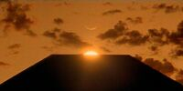

14

SATURDAY, JUNE 30

WHEN WHAT WHERE

07h – 11h Continental Breakfast Residence
Residence Guests Only

09h – 17h Registration Centre Open G1042

10h Plenary Session G1020
Official Welcome PLN
Announcements
Introductions
Welcome from Dr. Robert Garrison, Hon. Bob Wood and Dave McCarter. Garrison is national President of the Society. Wood is MPP for London West and an RASC London Centre member since 1958. Wood will bring greetings to open the General Assembly. Dave McCarter, London Centre President, will introduce the Guests of Honour and the session chairs.
In the workshop format, there will be a lively discussion of the topics by the presenters, and questions and contributions from the participants will be encouraged.

10h15 Coffee Break

10h30 Workshop 1 G1021*
The Surface of Mars WK1
Panelists: William K. Hartmann & Phil McCausland
Session Chair: Ronald B. Sawyer
Bill will discuss what the surface of Mars is like, and what it would be like to live there and to work there, with Phil a graduate student and London Centre member. Bill's novel "Mars Underground" is a human adventure on the surface of Mars. Bill has helped analyze the scientific results of every NASA probe to Mars. Phil is a Ph.D. student in geology at the University of Western Ontario, and has observed Mars for many years.

10h30 Workshop 2 G1019*
My Favourite Faint Fuzzies WK2
Panelist: David H. Levy & Chris Fleming
Session Chair: John Rousom
David will describe his recent observing experiences and will lead a discussion of the top telescopic targets. Renowned for his judgment at the eyepiece, David knows the night sky very, very well.
Chris is a London Centre member, an experienced observer, and chair of the R.A.S.C.’s Observing Certificates Committee

* Room is subject to change based on attendance. Follow the signs.

15

WHEN WHAT WHERE

11h30 Workshop 3 G1021*
Flying with the Space Shuttle Astronauts WK3
Panelists: Triple Nickel & Peter Ceravolo
Session Chair: Mike Hanes
Triple will describe his adventures on the Shuttle Training Aircraft and discuss how to land the space shuttle with Peter. Triple is a training pilot with NASA at Johnson Space Center in Houston. Peter owns a small aircraft and loves to fly.

11h30 Workshop 4 G1019*
Light Pollution Abatement WK4
Panelist: David Crawford & Rob Dick
Session Chair: John Bontje
Crawford, President of the International DarkSky Association, and Rob Dick, chair of the RASC LPA committee, will discuss how to combat light pollution and describe recent positive developments. The IDA is the world's first defence against light pollution, and Dave is its President and the leading advocate for the night sky. Rob is the chair of the R.A.S.C.'s LPA committee. Topics discussed will also include the Torrance Barrens Dark Sky Reserve.

12h30 – 13h30 Lunch LUN
Pre-ordered at registration time.
For fast food establishments near Fanshawe see page 8

13h30 Workshop 5 G1021*
Small Bodies of the Solar System WK5
Panelists: Robert Jedicke & David H. Levy
Session Chair: Peter G. Brown
Robert will explain how data from the Spacewatch project is used to calculate the asteroid population, and David will describe his current comet search projects. Session chair Peter Brown is the winner of the 2001 Plaskett Medal and will describe his thesis work on the Leonid meteoroids.

13h30 Workshop 6 G1019*
The MOST Project WK6
Panelists: Slavek Rucinski & Peter Ceravolo
Session Chair: Steve Gauthier
Slavek will describe the science program of Canada's astronomy satellite, MOST "Microvariability and Oscillations of STars" to be launched in 2002. Extremely long exposures from earth orbit -- almost 8 weeks -- will be used for photometry of stars. Slavek, a professor at University of Toronto, is a senior member of the science team. Peter is helping to design the optics.

14h15 Coffee Break

16

WHEN WHAT WHERE

14h30 Workshop 7 G1021*
Optics for Amateur Astronomy in the 21st Century
Panelists: Peter Ceravolo & Triple Nickel WK7
Session Chair: Dave McCarter
Renowned optical designer Ceravolo will discuss with enthusiastic amateur telescope maker Nickel what amateur astronomers will need to know to compete with factory-made telescopes.

14h30 Workshop 8 G1019*
Astronomy Software WK8
Panelists: Rajiv Gupta & Doug George
Session Chair: David Clark
Gupta, an expert image synthesizer, and George, creator of MaximDL, will lead a discussion of software. Whether it's for telescope pointing, CCD control, image enhancement, orbital calculation or star atlas presentation, there's a lot to talk about.

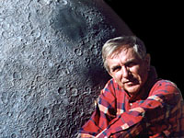
16h – 17h Ruth Northcott Lecture G1020
NOR
William K. Hartmann ¹

Mars and Monet: Artists on the Space Frontier

The Northcott Lecture will include an update on all the exciting
Mars work, Hartmann's experiences with the Mars Global
Surveyor project, and a slide show drawing connections between
science and art among painters and others who try to develop the artistic side of astronomy
and space exploration.
Greetings from Russ Montieth, Deputy Mayor, City of London
Introduction – Prof. Bob Garrison, National President

17h30 – 18h Group Photo Follow the sign PHO

18h30 – 22h Banquet Forwell Hall BNQ
Awards Presentation Student Union Building

22h Hospitality Suite Residence 620

¹ Dr. William K. Hartmann is known internationally as a scientist, writer, and painter. His research involves origin and evolution of planets and planetary surfaces, and the small bodies of the solar system. Specific research topics have included studies of cratering on the moon and Mars, leading the development of the currently most-accepted model for origin of the moon, telescopic observations of asteroids and satellites, participation in the Mariner 9 and Mars Global Surveyor Mars missions. Hartmann has authored three college level textbooks in astronomy and planetary science, all of which have been published in multiple editions, and roughly 200 technical papers. He has also published a number of popular non-fiction, illustrated books on astronomy, earth science, and the Sonoran Desert. In 1997 he published a novel about Mars. His paintings of astronomical themes have appeared in these books and in magazines and exhibits in the U.S., Russia, Japan, and Europe. He has twice had paintings commissioned by the NASA Fine Arts Program. He holds a Ph.D. in Astronomy and M.S. in Geology, both from the University of Arizona, and a B.S. in Physics from Pennsylvania State University.
17

SUNDAY, JULY 1

WHEN WHAT WHERE

07h – 11h Continental Breakfast Residence Lobby
Residence Guests Only

09h – 10h Devotional Service G1019
An inter-faith service conducted by London Centre member Stephen Arenburg.

10h – 12h R.A.S.C. Annual Meeting G1020
ANM
12h – 12h30 Awards and Certificates Presentation G1020

12h30 – 13h30 Lunch LUN
Pre-ordered at registration time.
For fast food establishments near Fanshawe see page 8

13h30 – 14h30 National Council Meeting G1020
NCM
14h – 17h Vendor Displays G1021
Swap Meet SWP
Book Signings

14h30 Workshop 9 G1020
"TMA-1: What is it?" WK9
Panelists: Heywood R. Floyd and Andrei Smyslov
A powerful magnetic source has recently been discovered on the floor of the crater Tycho. Floyd,
a member of the National Council of Astronautics, and Academician Smyslov will discuss various possible explanations and try to dispel some of the wild speculation that surrounds this strange phenomenon.

15h15 Coffee Break

15h30 Workshop 10 G1020
"The 2001 Total Solar Eclipse" WKX
Panelists: David H. Levy
Session Chair: Mike E. Flegel
Everyone who went to Africa to view the eclipse is welcome to join David, who will show his pictures and describe his adventures.

17h – 18h Hospitality Suite Open Residence 6th Floor
18

WHEN WHAT WHERE

18h – 21h Free Time – Dinner at a fine establishment
of your choice. London Centre members will
provide transportation to local favourites.

21h Hospitality Suite Residence 620
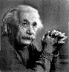
seti@fanshawe closing ceremony HSP

“Sure space-time is warped.
Just look at the London Centre.”

NOTES / AUTOGRAPHS / VISA STAMPS

19

MONDAY, JULY 2
WHEN WHAT WHERE

07h - 11h Continental Breakfast Residence
Residence Guests Only

09h45 – 17h Winery Tour Elgin County VIN
Strange as it may seem, the purpose of the Winery Tour is not to tour wineries. Really, it's just an excuse to get out of town and spend a relaxing day together, continuing conversations that you didn't have time to pursue because the weekend is so jam-packed with events. We will visit Quai du Vin Winery, where a light al fresco lunch will be served, then stop in Sparta, followed by a visit to Rush Creek Winery.
Expect a day of festive overtones, lots of dimension, with seductive depth, and a round, easy going finish. Create your own wine-words with a rich vocabulary of complex BS. Choose any noun from the describing list, and any adjective from the other list.
Describing - flavour, finish, style, overtones, nose, depth, or body.
Adjectives - Buttery, velvety, juicy, focused, easy going, spicy, mouth-filling, balanced, exciting, impertinent, rich, mellow, earthy, crisp, complex, pretty, harmonious, lively, toasty, big, festive, tangy, lots of dimension, clean, rich, round, warm, heady, zesty, soft, expressive, poised, expanding, substantial, intriguing, shy, teasing, whimsical, enrolling, deserving, tasty, responsible, outrageous, hinting, attractive, silken, delicate, elegant, dashing, seductive, captivating, irresistible, unrestrained.

Canada Day Activities
The Forest City's Canada Day downtown festivities “The Great Canadian Celebration” will be held at Harris Park, along the Thames River. The 2001 celebration will include live music, food, family fun and fireworks.
The Royal Canadian Big Band Music Festival is on during the weekend at a variety of venues including the Cherryhill Village Mall and the Market Square.

Getting Around London
The main way to the city is the 401 or 402. The best connection from the 401 to Fanshawe College is Highbury Ave. In the south, the main arteries East-West are Southdale and Commissioners Road. In the north the East-West routes are Oxford and Fanshawe. Downtown, use Dundas/Riverside. Queens Ave. is one-way Westbound. King Street is one-way Eastbound. North-South through the city heart take Wellington Road then Richmond. Most major North-South roads cross Oxford Street so you will not have trouble getting back to the campus.

20

AWARDS
We have decided to spread the awards presentations out during the G.A. There are quite a few awards to be given out this year! The Plaskett, Service and Newcomb will be presented on Saturday during the Gala Banquet. The Messier, NGC, and Light Pollution Abatement on Friday at the BBQ and the Chant, Chilton and Membership Certificates, Sunday, after the Annual Meeting. The seti@fanshawe contest closes at the Sunday Hospitality party.

Chant Medal
Established in 1940 in appreciation of the great work of the late Prof. C. A. Chant in furthering the interests of astronomy in Canada. This medal is awarded to an amateur astronomer resident in Canada on the basis of the value of the work carried out in astronomy and closely allied fields of the original investigation.
Richard Huziak, Saskatoon Centre
Accepting on behalf of Richard Huziak is Jim Young, Saskatoon Centre
Presented by Dr. John Percy, RASC Gold Medal 1962, Service Award 1977

Plaskett Medal
Established in 1987 in recognition of the pivotal role played by John Stanley Plaskett in the establishment of astrophysical research in Canada. The award, consisting of a gold medal, is made annually to the graduate from a Canadian University who is judged to have submitted the most outstanding Doctoral Thesis in astronomy and astrophysics in the preceding two years.
Peter G. Brown, London Centre
Presented by Dr. Ian Halliday, RASC Gold Medal 1949, RASC Honourary President 1989-1993

Ken Chilton Prize
Established in 1977 in remembrance of Ken E. Chilton, an active member of the Hamilton Centre. The prize is awarded annually to an amateur astronomer resident in Canada, in recognition of a significant piece of astronomical work carried out or published during the year.
Michael Boschat, Halifax Centre
Accepting on behalf of Mr. Boschat is Dave Lane, Halifax Centre
Presented by Dr. David H. Levy, Honorary President, Montreal Centre and Honorary President, Kingston Centre

Service Award
This bronze medal is a major award of the Society given to a member in recognition of outstanding Service, rendered over an extended period of time, where such service has had a major impact on the work of the Society and/or of a Centre of the Society.
David Turner, Halifax Centre
John Rousom, London Centre
Presented by Mr. Randy Attwood, RASC Past President

21

Simon Newcomb Award
For literary achievement. The Simon Newcomb Award is named in honour of the famous astronomer Simon Newcomb (1835-1909) who was born in Nova Scotia. Established in 1978, it is intended to encourage members of the Society to write on the topic of astronomy for the Society or the general public, and to recognise the best published works. It is not intended for those who normally publish articles or papers on astronomy as part of their professional work.
Dan Falk, Toronto Centre
Presented by Mr. Michael S.F. Watson, RASC Treasurer, Newcomb Award Winner

Light Pollution Abatement Certificate
A Light Pollution Abatement merit certificate that is presented to communities or to a business that chooses good lighting fixtures and practices.
City of Oshawa. Accepted by Mr. Vanderkwaak
Presented by Dr. David Crawford, RASC Honourary Member

AROUND LONDON from page 8

DINING OUT
Pizza
- East Town Pizza - 681 Highbury Ave just south of Dundas St. The best pizza in London! Also winners of the World best Pizza. The London Centre’s after-meeting hang out.
- Tony’s - 980 Dundas at Quebec. Great Panzerotti.

Fine Dining – Eric’s Picks
- Michael’s on the Thames; Under The Volcano; Villa Cornelia; Marienbad; Marla Jane’s; Mongolian Grill; Great West Steak House; Waldo’s; Oscar Taylors; Horse & Hound; Mykonos; Ah-So Gardens; Mandarin; London Grill. See your London Visitor Booklet for types and locations.

BEER AND LIQUOUR
- Beer Store - 1600 Dundas St. E, east of 1st Street, next to Taco Bell.
- Liquor (LCBO) - 900 Oxford St. at Gammage (next to Kelsey’s) and 1616 Dundas St. E (next to the Beer Store).

PHARMACY
- Shoppers Drug Mart – Northland Mall, Highbury Ave. at Huron St.

FOOD AND VARIETY
- Mac’s – Oxford Street at First Street, across from the College.
- Mini Mart - 2nd Street at Oxford St., across from the College.
- Oxbury Mall – Oxford St. at Highbury Ave.

22

THANKS TO
- Members of the London Centre.
- Spouses of the Committee and Volunteer Members.
- Rob McCarter, of McCarter Consulting, for the basic design, training and implementation of the Web-based registration system.
- Steve Gauthier donating and breathing life into Polaris, a dual processor Linux PC, situated at Linkdata Communications.
I'm sorry Dave,
I'm afraid I can't do that.
- Dave Clark for donating the Internet connectivity, maintaining static content, along with Peter Jedicke, and writing all the queries.
- Matt Meier, Jamie McCarter, Bill Gardner, Miranda Sawyer, Eberley Clark and others who contributed to the Web pages.
- Our Sponsors and prize doners.
- Stitch Graphix for the logo and shirts.
- Fanshawe College.
- U.W.O. Physics and Astronomy Department.
- Members of the Spirit of Jazz Music Group.

DONATIONS
More items may have been acquired since the printing of this booklet. For a complete list of the prizes, please visit the GA 2001 web site.
- ETX 125EC, Autostar, tripod & eyepiece from Meade Instruments
- The Celestial Sphere video and laminated full-sky charts donated by Starlight Theatre
- Earth-Centred Universe v3.1A donated by Nova Astronomics
- Stargazer Steve 15cm Dobsonian Telescope
- Astronomy Today book donated by Dave McCarter
- Starry Night Pro donated by Space.com
- Eyepieces and Camera adapter donated by McKittrick’s Ltd
- 40mm Tele Vue Plossl donated by Mike Flegel
- Music Box, Cherished Teddies, GA Apes, Sun Catcher donated by Angela and Dave Clark
- Comet Explorer CD-ROM donated by Douglas George, Peter Ceravolo, Paul Boltwood, and Jonathan Buchanan
- Cosmic Phenomena book from Perceptor
- 7x50 Tento Binoculars from Kahn Scope Centre
- Vista 80mm Refractor from O'Neil Photo and Optical Inc
23

ACKNOWLEDGMENTS
Many people deserve thanks for their hard work in making this General Assembly a reality. Thanks to the volunteers who helped out during the week and weekend with the observing, registration, hospitality suite, child care, transportation, astronomy education workshops and other activities.

Organizing Committee |  | Volunteers
Angela Clark | Registration | Steve Ahrenberg
Dave Clark | Web Master, Registration | Margaret Campbell
Eric Clinton | Programme, Transportation | Dylan Clark
Robert Duff | Astronomy Education Workshop | Eberley Clark
Michael Flegel | seti@fanshawe | Everett Clark
Chris Fleming | Observing, Promotion | Mike Costa
Steve Gauthier | Secretary, Web host | Donise Flegel
Dianne Jedicke | Hospitality | Erin Gauthier
Peter Jedicke | Chairman, Meetings, Workshops | Heather Gauthier
David McCarter | Centre President, Workshops | Bill Gardner
Joe O’Neil | Vendors and Prizes | Joe Gurney
Shawn Osterberg | Treasurer, Registration | Joan Henderson
Valerie Rausch | Meals, Hospitality | Derek Hitchens
Darle Rousom | Winery Tour, Transportation | Carolyn Horley
John Rousom | Winery Tour | Ingrid Hutchinson
Ronald Sawyer | seti@fanshawe, Signage | Tim Kunz
Kelly Sibthorpe | Astronomy Education Workshop | Karen Khan
Harold Tutt | Facilities & Residence, Meals | Dave Nopper
 |  | Becca Rausch
 |  | Dave Rubenhagen
 |  | Rob Russell
 |  | Colleen Sawyer
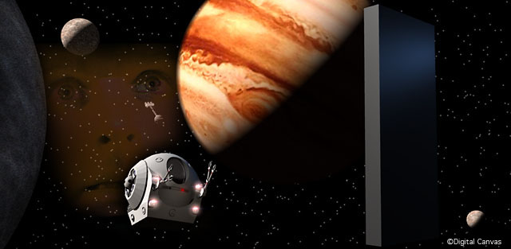 |  | Miranda Sawyer
 |  | Ram Shinani
 |  | Glen Spooner
 |  | Neil Whyte

Thanks for taking this trip with us

2001: a space r.a.s.c.

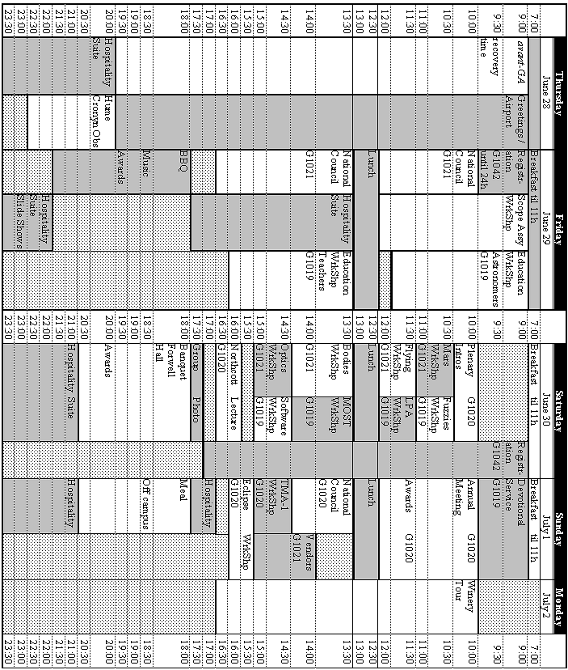

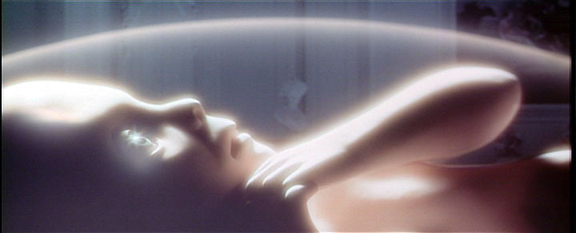 www.rasc.ca\ga2001

